UNITED STATES
SECURITIES AND EXCHANGE COMMISSION
Washington, D.C. 20549

SCHEDULE 14A
Proxy Statement Pursuant to Section 14(a) of the
Securities Exchange Act of 1934
(Amendment No.)

Filed by the Registrant ☒
Filed by a party other than the Registrant ☐
Check the appropriate box:

☐ | Preliminary Proxy Statement

☐ | Confidential, for Use of the Commission Only (as permitted by Rule 14a-6(e)(2))

☐ | Definitive Proxy Statement

☒ | Definitive Additional Materials

☐ | Soliciting Material under §240.14a-12
ALIGOS THERAPEUTICS, INC.
(Name of Registrant as Specified in its Charter)
(Name of Person(s) Filing Proxy Statement, if other than the Registrant)
Payment of Filing Fee (Check the appropriate box):

☒ | No fee required

☐ | Fee paid previously with preliminary materials

☐ | Fee computed on table in exhibit required by Item 25(b) per Exchange Act Rules 14a-6(i)(1) and 0-11

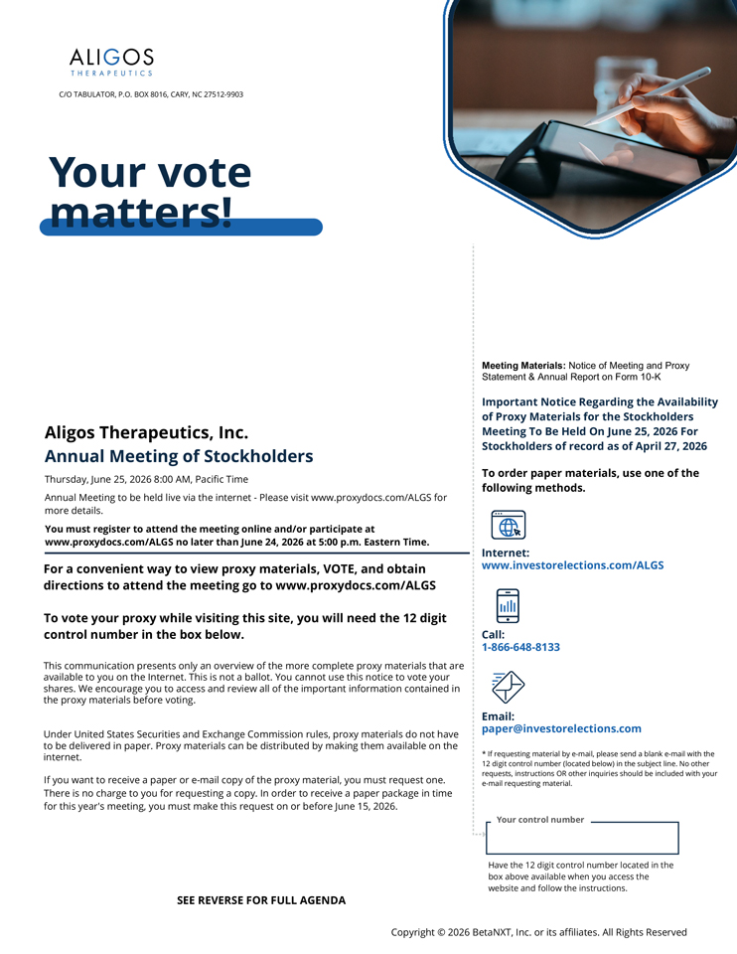
C/O TABULATOR, P.O. BOX 8016, CARY, NC 27512-9903 Your vote matters! Meeting Materials: Notice of Meeting and Proxy Statement & Annual Report on Form 10-K Important Notice Regarding the Availability of Proxy Materials for the Stockholders Aligos Therapeutics, Inc. Meeting To Be Held On June 25, 2026 For Stockholders of record as of April 27, 2026 Annual Meeting of Stockholders To order paper materials, use one of the Thursday, June 25, 2026 8:00 AM, Pacific Time Annual Meeting to be held live via the internet—Please visit www.proxydocs.com/ALGS for following methods. more details. You must register to attend the meeting online and/or participate at www.proxydocs.com/ALGS no later than June 24, 2026 at 5:00 p.m. Eastern Time. Internet: For a convenient way to view proxy materials, VOTE, and obtain www.investorelections.com/ALGS directions to attend the meeting go to www.proxydocs.com/ALGS To vote your proxy while visiting this site, you will need the 12 digit control number in the box below. Call: 1-866-648-8133 This communication presents only an overview of the more complete proxy materials that are available to you on the Internet. This is not a ballot. You cannot use this notice to vote your shares. We encourage you to access and review all of the important information contained in the proxy materials before voting. Email: paper@investorelections.com Under United States Securities and Exchange Commission rules, proxy materials do not have to be delivered in paper. Proxy materials can be distributed by making them available on the * If requesting material by e-mail, please send a blank e-mail with the internet. 12 digit control number (located below) in the subject line. No other requests, instructions OR other inquiries should be included with your If you want to receive a paper or e-mail copy of the proxy material, you must request one. e-mail requesting material. There is no charge to you for requesting a copy. In order to receive a paper package in time for this year’s meeting, you must make this request on or before June 15, 2026. Your control number Have the 12 digit control number located in the box above available when you access the website and follow the instructions. SEE REVERSE FOR FULL AGENDA Copyright © 2026 BetaNXT, Inc. or its affiliates. All Rights Reserved

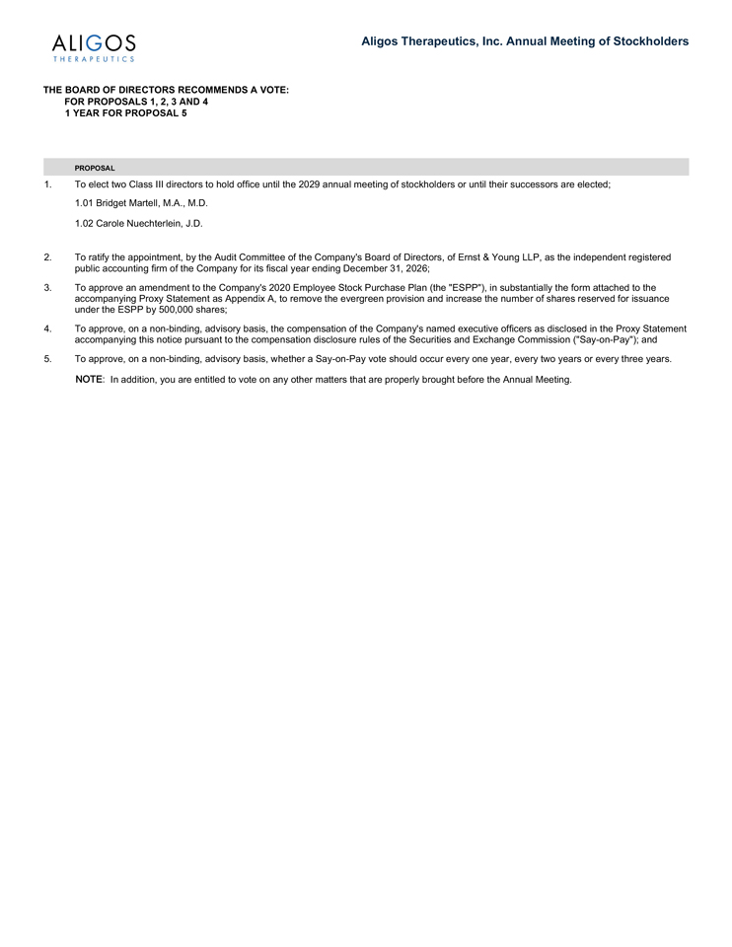
Aligos Therapeutics, Inc. Annual Meeting of Stockholders THE BOARD OF DIRECTORS RECOMMENDS A VOTE: FOR PROPOSALS 1, 2, 3 AND 4 1 YEAR FOR PROPOSAL 5 PROPOSAL 1. To elect two Class III directors to hold office until the 2029 annual meeting of stockholders or until their successors are elected; 1.01 Bridget Martell, M.A., M.D. 1.02 Carole Nuechterlein, J.D. 2. To ratify the appointment, by the Audit Committee of the Company’s Board of Directors, of Ernst & Young LLP, as the independent registered public accounting firm of the Company for its fiscal year ending December 31, 2026; 3. To approve an amendment to the Company’s 2020 Employee Stock Purchase Plan (the “ESPP”), in substantially the form attached to the accompanying Proxy Statement as Appendix A, to remove the evergreen provision and increase the number of shares reserved for issuance under the ESPP by 500,000 shares; 4. To approve, on a non-binding, advisory basis, the compensation of the Company’s named executive officers as disclosed in the Proxy Statement accompanying this notice pursuant to the compensation disclosure rules of the Securities and Exchange Commission (“Say-on-Pay”); and 5. To approve, on a non-binding, advisory basis, whether a Say-on-Pay vote should occur every one year, every two years or every three years. NOTE: In addition, you are entitled to vote on any other matters that are properly brought before the Annual Meeting.

